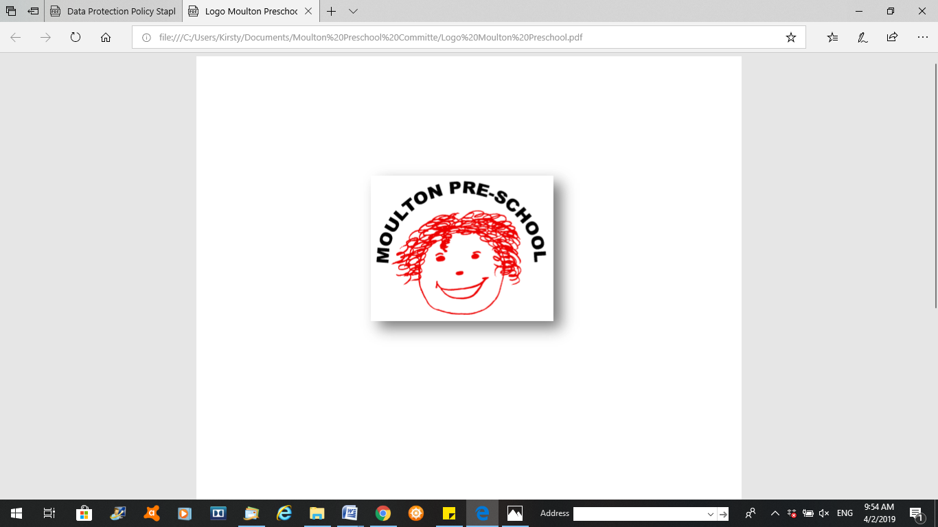

**Moulton Pre-School – Grievance Policy and Procedure**

|  |  |
| --- | --- |
| **Version:** | 2.1 |
| **Author:** | Emily Short |
| **Approved and signed by:** | Moulton Pre-School Committee |
| **Date:** | January 2024 |
| **Review Date:** | 01/04/2026 |

# Grievances Policy and Procedure

***Moulton Pre-school is committed to safeguarding and promoting the welfare of children, young people and adults at all times and expects everybody working within this setting to share this commitment.***

## Introduction

The following procedure should be followed in order to settle all grievances concerning any employee(s) of Moulton Preschool.

## Principles

The key objective of the procedure is to allow grievances to be settled quickly, fairly and at the lowest possible level within Moulton Preschool, whilst allowing employees the opportunity to appeal to a higher level if necessary.

The procedure covers all employed staff in Moulton Preschool who have a grievance.

Employees are encouraged to raise concerns verbally with the Manager or committee prior to raising a formal grievance. Where possible, we will deal with concerns informally unless the matter is considered too serious, in which case the formal grievance procedure will apply. Examples of this might be sexual harassment.

Employees are entitled to be accompanied to a grievance meeting and appeal, by a trade union representative or by a work colleague, who has not been involved in the case or situation.

## Procedure

The Moulton Preschool policy is to encourage free interchange and communication between all staff members. This ensures that questions and problems can be aired and resolved quickly and that grievances are settled informally.

## Informal procedure

If an employee has a complaint about their individual circumstances at work, then they are entitled to raise a grievance. Employees are expected to discuss ordinary day-to-day issues informally with the Pre-School through supervision meetings or if necessary, request a separate meeting. Where this is not possible employees should raise their concerns verbally with a committee member, prior to raising a formal grievance.

If, after seeking to resolve concerns informally employees are not satisfied, then they should write to the Chairperson of the committee, explaining their grievance.

## Formal procedure

Employees must provide, in writing, the nature of the alleged grievance and send the written complaint to the Pre-School leader.

Where the grievance is against the Pre-School leader the matter should be raised with the Chairperson of the committee.

Normally within 5 working days of receiving a grievance, the Pre-School leader will write to the employee, inviting them to attend a meeting where the alleged grievance can be discussed. The meeting should be scheduled to take place as soon as reasonably possible, and normally at least 24 hours' notice of this meeting should be provided to the employee.

Employees are required to take all reasonable steps to attend the meeting. However, should, for a reasonably unforeseen reason, either the employee, their companions, or the Pre-School leader be unable to attend the meeting, it must be rearranged. We are only able to rearrange meetings on one occasion.

Should an employee’s companion be unable to attend then the employee should make contact within 5 days of the date of the letter to arrange an alternative date that falls within 10 days of the original date provided. These time limits may be extended by mutual agreement.

At the meeting the employee must inform the Pre-School leader hearing the grievance what the basis for the complaint is.

After the final meeting, the Pre-School leader/ Committee member hearing the grievance must write to the employee informing them about any decision and offering the right of appeal. This letter should be sent within 10 working days of the grievance meeting and should include the details of how to appeal.

Should the employee consider that the grievance has not been satisfactorily resolved, then they must set out their grounds of appeal in writing within 7 working days of receipt of the decision letter, confirming that they wish to appeal against the decision or failure to make a decision.

Within 5 working days of receiving an appeal letter, the employee will be invited to attend an appeal hearing where the alleged grievance can be discussed. The appeal meeting should be scheduled to take place as soon as reasonably possible. The appeal will be heard by a member of the committee.

Employees are required to take all reasonable steps to attend the appeal hearing. However, should, for a reasonably unforeseen reason, either the Chair of the meeting, the employee, or their companions be unable to attend the meeting, it must be rearranged.

Should an employee’s companion be unable to attend then the employee should make contact within 5 days of the date of the letter to arrange an alternative date that falls within 10 days of the original date provided. These time limits may be extended by mutual agreement.

After the appeal meeting, the appeal hearing Chair must write to the employee informing them of the employer’s final decision. This letter should be sent within 10 working days of the appeal hearing.

This is the final stage of the procedure.