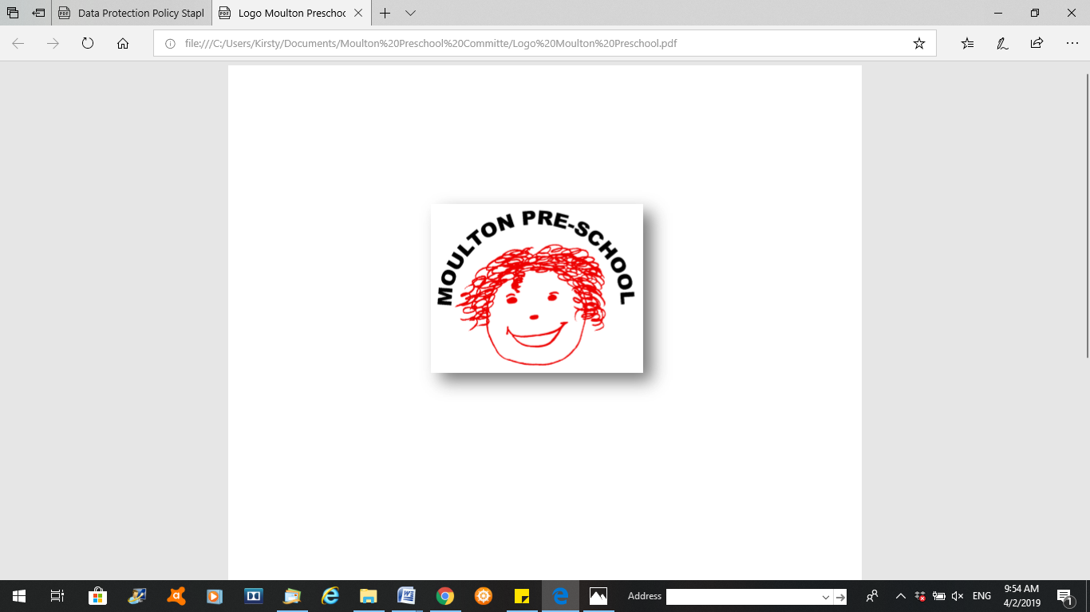

**Moulton Pre-School – Selecting Play Equipment and Toys Policy**

|  |  |
| --- | --- |
| **Version:** | 2.1 |
| **Author:** | Emily Short |
| **Approved and signed by:** | Moulton Pre-School Committee |
| **Date:** | March 2024 |
| **Review Date:** | 01/04/2026 |

# Selecting Play Equipment and Toys

***Moulton Pre-school is committed to safeguarding and promoting the welfare of children, young people and adults at all times and expects everybody working within this setting to share this commitment.***

The toys and equipment in pre-school provide opportunities for children, with adult help, to develop new skills and concepts in the course of their play and exploration. The equipment we provide:

* is appropriate for the ages and stages of the children
* offers challenges to developing physical, social, personal and intellectual skills
* features positive images of people, both male and female, from a range of ethnic and cultural groups, with and without disabilities
* includes a range of raw materials which can be used in a variety of ways and encourages an open-ended approach to creativity and problem-solving
* will enable children, with adult support, to develop individual potential and move towards required learning goals
* conforms to all relevant safety regulations and is sound and well made.