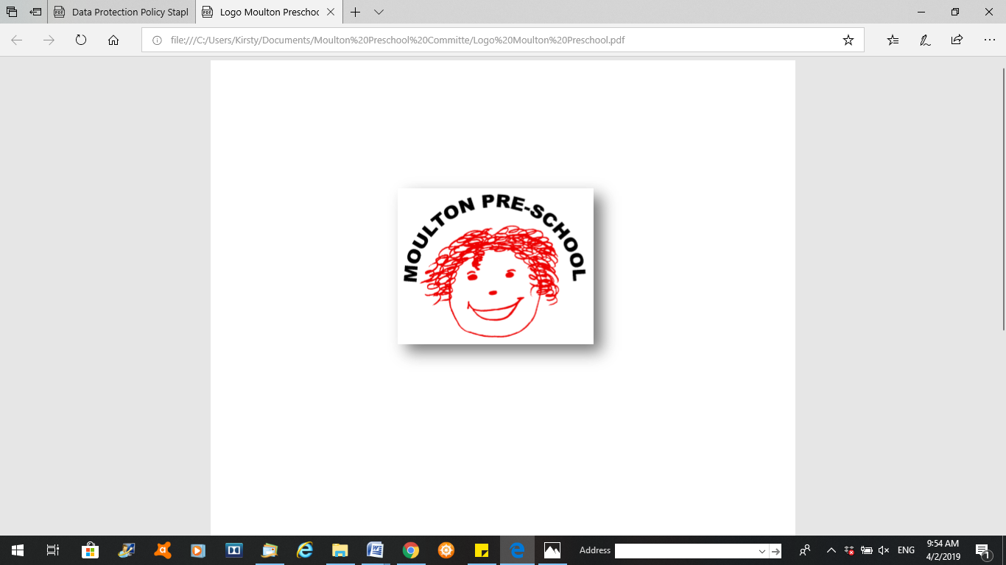

**Moulton Pre-School – No Smoking, Alcohol and Substance Misuse Policy**

|  |  |
| --- | --- |
| **Version:** | 3.0 |
| **Author:** | Emily Short |
| **Approved and signed by:** | Moulton Pre-School Committee |
| **Date:** | February 2024 |
| **Review Date:** | 01/04/2026 |

# No Smoking, Alcohol and Substance Misuse

***Moulton Pre-school is committed to safeguarding and promoting the welfare of children, young people and adults at all times and expects everybody working within this setting to share this commitment.***

**Policy Statement:** Smoking is prohibited; including the use of e-cigarettes. Alcohol and drugs are not allowed at the premises of the preschool at any time including the outside area.

All staff, parents/carers, students, and volunteers will be made aware of the policy.

## Smoking;

* There are no smoking signs displayed in the hall at all times.
* If a parent/carer, student or volunteer was found smoking they will be asked to leave the premises immediately.
* If anyone approaches the children when they are outside playing and they are smoking they will be asked to move away.
* If a member of staff is found smoking, disciplinary procedures will be initiated against the member of staff.
* Smoking is not permitted during working hours. Staff who wish to smoke must do so only on their allocated breaks. Any smoking must be off the premises. Staff will need to cover their uniform to smoke and must ensure they come back clean smelling and hands washed to limit the effect of passive smoking.
* E-cigarettes are not permitted to be used on the premises.
* It is a criminal offence for employees to smoke in smoke-free areas, with a fixed penalty of £50 or prosecution and a fine of up to £200.

**Alcohol and substance misuse**

## If a Parent/carer is suspected of being unfit to care for a child due to alcohol or substance abuse

* If a parent/carer arrives to collect a child and is suspected of being in an unfit condition to care for that child, we class that child as being un-collected and activate our Non-Collection of Children Policy.
* A dated record is made of the incident.
* Advice and support will be offered to the parent/carer.
* If such incidents are repeated or become a concern, then we activate our Safeguarding Children and Child Protection Policy with reference to the neglect section.

## If a member of staff is suspected of being unfit to care for children due to alcohol or substance abuse

* If a member of staff arrives at the setting in an unfit condition to care for children due to alcohol or substance abuse, then they are classed as absent from work and are sent home.
* This absence is classed as unauthorised and a dated record will be made of the incident and added to the member of staff record.
* The member of staff will receive no pay for the missed session.
* Advice and support will be offered to the member of staff.
* If such incidents are repeated or become a concern then we activate the Staff Disciplinary Procedure.
* Legal framework
* The Smoke-free (Premises and Enforcement) Regulations (2006)
* The Smoke-free (Signs) Regulations (2012)

# 