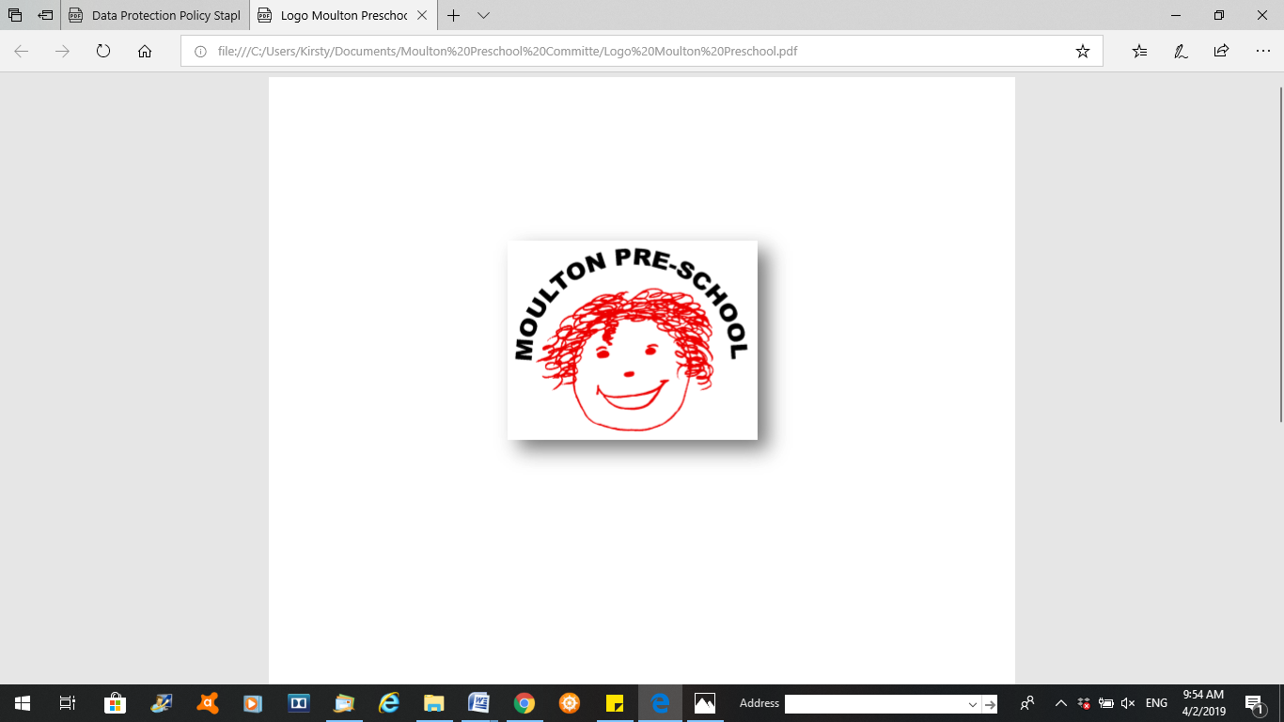

**Moulton Pre-School – Employment policy**

|  |  |
| --- | --- |
| **Version:** | 2.1 |
| **Author:** | Emily Short |
| **Approved and signed by:** | Moulton Pre-School Committee |
| **Date:** | January 2024 |
| **Review Date:** | 01/04/2026 |

# Employment

***Moulton Pre-school is committed to safeguarding and promoting the welfare of children, young people and adults at all times and expects everybody working within this setting to share this commitment.***

## Policy statement

We meet Safeguarding and Welfare Requirements of the Early Years Foundation Stage ensuring that our staff and volunteers are appropriately qualified, and we carry out checks for criminal and other records through the Disclosure and Barring Service (DBS) in accordance with statutory requirements.

## Procedures

## Vetting and staff selection

* We work towards offering equality of opportunity by using non-discriminatory procedures for staff recruitment and selection.
* All our staff have job descriptions, which set out their roles and responsibilities.
* We welcome applications from all sections of the community. Applicants will be considered on the basis of their suitability for the post, regardless of disability, gender reassignment, pregnancy and maternity, race, religion or belief, sexual orientation, sex, age, marriage or civil partnership. Applicants will not be placed at a disadvantage by our imposing conditions or requirements that are not justifiable.
* We follow the requirements of the Early Years Foundation Stage and Ofsted guidance on checking the suitability of all staff and volunteers who will have unsupervised access to children. This includes obtaining references and ensuring they have a satisfactory enhanced criminal records check with barred list(s) check through the DBS. This is in accordance with requirements under the Safeguarding Vulnerable Groups Act (2006) and the Protection of Freedoms Act (2012) for the vetting and barring scheme.
* Where an individual is subscribed to the DBS Update Service, we carry out a status check of their DBS certificate, after checking their identity and viewing their original enhanced DBS certificate to ensure that it does not reveal any information that would affect their suitability for the post.
* We keep all records relating to the employment of our staff and volunteers; in particular those demonstrating that suitability checks have been done, including the date of issue, name, type of DBS check and unique reference number from the DBS certificate, along with details of our suitability decision.
* We require that all our staff and volunteers keep their DBS check up to date by subscribing to the DBS update Service throughout the duration of their employment with us.
* Our staff are expected to disclose any convictions, cautions, court orders, reprimands and warnings which may affect their suitability to work with children – whether received before, or at any time during, their employment with us.
* We obtain consent from our staff and volunteers to carry out on-going status checks of the Update Service to establish that their DBS certificate is up to date for the duration of their employment with us.
* Where we become aware of any relevant information which may lead to the disqualification of an employee, we will take appropriate action to ensure the safety of children. In the event of disqualification, that person’s employment with us will be terminated.

**Safer Recruitment**

* We are committed to safeguarding and protecting all children and young people by implementing robust safer recruitment practices
* identifying and rejecting applicants who are unsuitable to work with children and young people
* responding to concerns about the suitability of applicants during the recruitment process
* responding to concerns about the suitability of employees and volunteers once they have begun their role
* ensuring all new staff and volunteers participate in an induction which includes child protection

## Changes to staff

* We inform Ofsted of any changes in the person responsible for our setting.

## Training and staff development

* Our setting Manager and Deputy hold a Level 5 and 6 qualification in Childcare and Education and a minimum of half of our staff hold a Level 2 or higher qualification.
* We provide regular in-service training to all staff - whether paid staff or volunteers - through the Pre-school Learning Alliance and external agencies.
* Our setting budget allocates resources to training.
* We provide staff induction training in the first week of employment. This induction includes our Health and Safety Policy and Safeguarding Children and Child Protection Policy. Other policies and procedures will be introduced within an induction plan.
* We support the work of our staff by holding regular supervision meetings and appraisals.
* We are committed to recruiting, appointing and employing staff in accordance with all relevant legislation and best practice.
* The training provider for our training recruitment is NSPCC.

## Staff taking medication/other substances

* If a member of staff is taking medication which may affect their ability to care for children, we ensure that they seek further medical advice. Our staff will only work directly with the children if medical advice confirms that the medication is unlikely to impair their ability to look after children properly.
* Staff medication on the premises will be stored securely and kept out of reach of the children at all times.
* If we have reason to believe that a member of our staff is under the influence of alcohol or any other substance that may affect their ability to care for children, they will not be allowed to work directly with the children and further action will be taken.

## Managing staff absences and contingency plans for emergencies

* Staff will take their holiday leave when the setting is closed. In exceptional circumstances leave may be taken with sufficient notice and approval of the Manager and committee.
* Where staff are unwell and take sick leave in accordance with their contract of employment, we organise cover to ensure ratios are maintained.
* Sick leave is monitored, and action is taken where necessary in accordance with the contract of employment.