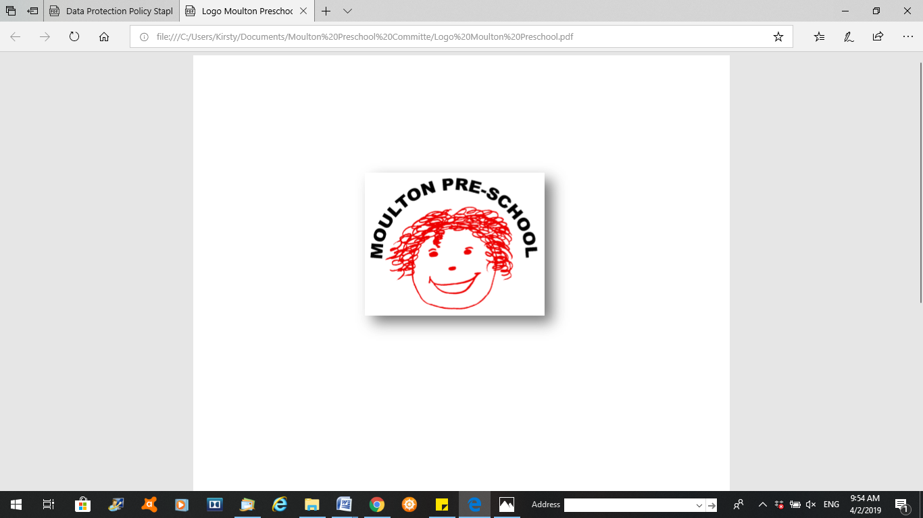

**Moulton Pre-School – Disciplinary Policy**

|  |  |
| --- | --- |
| **Version:** | 3.0 |
| **Author:** | Emily Short |
| **Approved and signed by:** | Moulton Pre-School Committee |
| **Date:** | January 2024 |
| **Review Date:** | 01/04/2026 |

1. **Introduction**
   1. This procedure is designed to encourage all employees to achieve high standards of conduct and work performance and also aims to provide a fair, effective and consistent method of dealing with disciplinary matters.
2. **Key principles**

* Employees are expected to know the standard of conduct or work performance expected of them.
* Employees will be provided with a management statement of the case prior to any disciplinary meeting and will be allowed to respond to any alleged fault or failing at the meeting.
* An employee is entitled to be accompanied by a trade union representative or work colleague employed by the setting, to a disciplinary meeting and appeal. Other external representatives may not accompany the employee.
* For minor or isolated infringements of rules or expected behavior, managers and supervisors should give employees informal advice, coaching and counselling as part of their supervisory duties.
* Where an employee’s conduct or performance fails to improve as a result of advice, coaching or counselling, or where the offence is more serious, then the disciplinary procedure will be applied.
* A prompt and thorough investigation into the concerns will take place prior to a disciplinary meeting taking place. The employee will be informed that an investigation is taking place as soon as possible.
* The employee must take all reasonable steps to attend the disciplinary meeting and any appeal.
* Except in cases of gross misconduct, no employee will be dismissed for a first offence.

1. **Categories of gross misconduct**
   1. Gross misconduct is a category which can include:

* Theft, fraud and deliberate falsification of records, expenses, qualifications and other offences of dishonesty.
* Physical violence.
* Serious bullying or harassment.
* Deliberate damage to property.
* Conviction of a criminal offence relevant to the employee’s role.
* Gross negligence.
* Serious insubordination.
* Misuse of the setting’s property or name.
* Misuse of electronic communications which defames individuals or brings the organisation into disrepute.
* Bringing the organisation into serious disrepute.
* Serious incapability whilst on duty brought on by alcohol or illegal drugs.
* Serious negligence which causes or might cause unacceptable loss, damage or injury.
* Serious infringement of health and safety rules.
* Serious failure to comply with policies, procedures and legal requirements that safeguard children.
* Serious breach of the early years setting’s and statutory policies.
* Serious breach of confidentiality (subject to the Public Interest (Disclosure) Act 1998).
* Defaming or bad mouthing the setting on social networking sites
* Serious breaches of the Data Protection Act.
* Bribery and corruption.

This is not an exhaustive list

1. **Steps prior to deciding to take disciplinary action** 
   1. When any incident of misconduct or negligence or poor performance is alleged to have occurred, the manager must establish the facts to decide whether there is a need for a disciplinary meeting.
   2. Where appropriate/possible, signed written statements should be obtained as quickly as possible from the individual(s) concerned and should include where possible, dates, times, details of those present and the issues of concern.
2. **Procedure**
   1. At the earliest opportunity the manager must inform the employee that an allegation/incident has occurred and that an investigation is to take place.
   2. Following an appropriate investigation, the manager must prepare a written statement regarding the employee’s alleged conduct or characteristics, or of the circumstances which have led to the contemplation of taking disciplinary action.
   3. The manager or supervisor must send the statement and any witness statements to the employee including any evidence that will be relied upon at the meeting and invite them to attend a disciplinary meeting to discuss the matter. The employee should also be informed of their right to be accompanied at the meeting. Employees should be given an appropriate amount of notice of the meeting in order to prepare their response and to contact any witnesses that they wish to call to the meeting to give evidence.
   4. A disciplinary meeting must take place before any disciplinary action is taken. At the meeting, the manager or supervisor should ensure that the circumstances of the complaint against the employee are fully discussed, and the employee is provided with an opportunity to respond to the management case. The manager will then decide whether or not to issue a disciplinary penalty. The outcome of the disciplinary meeting must be confirmed in writing within 10 working days, to include the right of appeal and to whom to address any appeal letter.
3. **Appeal**
   1. Any employee who feels they have been disciplined unfairly may appeal in writing to the person named in the disciplinary letter. All appeals must be submitted in writing, clearly setting out the grounds for appeal, within 7 working days of the date of the disciplinary meeting letter.
   2. Normally an appeal meeting will be arranged with the employee together with a member of the committee within 15 working days of the employee’s request.
   3. Appeals will normally be held within 15 working days of the date of the original disciplinary meeting. A letter detailing the outcome of the appeal should be issued within 10 working days of the appeal meeting.
4. **Disciplinary penalties**
   1. Managers should not issue any disciplinary penalties without a formal meeting.
   2. There are five disciplinary penalties, which may result from misconduct:

* Formal verbal warning (first formal warning).
* Written warning.
* Final written warning.
* Dismissal with notice.
* Summary dismissal.
  1. The gravity of the offence will determine which disciplinary penalty is issued. All disciplinary penalties must be confirmed in writing.

1. **Formal verbal warning**
   1. Minor breaches of organisational discipline, misconduct or timekeeping, or failure to meet performance criteria, may result in a formal verbal warning given by the manager. The manager may give this at a disciplinary meeting with the employee. This warning should be confirmed in writing.
   2. The employee may be accompanied to the meeting by a work colleague or a trade union representative.
   3. The warning will be placed on the employee’s personnel file. After a period of three months, if no further disciplinary action has been found necessary and the minor breach has been resolved, the warning will expire.
2. **Written warnings**
   1. If the infringement is regarded as more serious, or the employee’s work or conduct are considered unsatisfactory after they have received a formal verbal warning and after a period has elapsed in which the employee has had time to remedy their work or conduct, a disciplinary meeting conducted by the manager will be held.

The employee will be informed of the nature of the complaint and such evidence as may exist and will be given an opportunity to respond. The employee will be told of the decision and given a letter of confirmation within 10 working days of the disciplinary meeting. The written confirmation will state:

* The date of the disciplinary meeting and those present.
* The penalty imposed.
* Details of the misconduct, poor performance or poor time keeping that has occasioned a warning and the performance required or the change in behavior required.
* Details of any necessary action to remedy the situation, any period of review, extra training or supervision etc., or the possibility for redeployment/demotion.
* That any further misconduct etc. will result in a further disciplinary meeting and will normally result in a confirmed final warning, which if unheeded will result in dismissal with appropriate notice.
* That there is a right of appeal.

9.2 After a period of six months, if no further disciplinary action has been found necessary and the minor breach has been resolved, the warning will expire.

1. **Final written warning**
   1. If the employee’s work or conduct fails to improve, or where the infringement is sufficiently serious, the manager will follow the same procedures as for issuing a written warning. If proven, a final warning, which will be in writing, will be given to the employee warning that any further misconduct will result in dismissal with appropriate notice.
   2. After a period of twelve months, if no further disciplinary action has been found necessary and the breach has been resolved, the warning will expire.
2. **Gross misconduct**
   1. Employees dismissed with notice will be paid for this notice period. An employee may be dismissed without notice if there has been an act of gross misconduct, or a major breach of duty or conduct that brings the organisation into disrepute. The employee will be suspended with pay while the circumstances of the alleged gross misconduct are investigated.
   2. A dismissal must be confirmed in writing within 10 working days of the date of the disciplinary meeting. As well as covering the points in paragraphs 9.1, the letter should also include details of any outstanding money owed to the employee, how and when it will be paid and the final date of employment.
   3. In certain cases where a member of staff is dismissed from the organisation or internally disciplined because of misconduct relating to a child, we inform the Independent Safeguarding Authority.
3. **Suspension**
   1. Suspension should be used sparingly in circumstances where the manager needs to conduct an investigation prior to a hearing where it is felt that the impact of not suspending the employee during the period would be likely to be more detrimental than suspending them.
   2. Cases which involve potential gross misconduct will usually result in suspension; particularly when relationships have broken down or where the setting’s property or responsibilities to other parties are involved, or where the employee’s presence may prejudice the inquiry.
   3. Suspension should be kept brief and reviewed to ensure that it is not unnecessarily protracted.
   4. Where a member of staff is suspended because of alleged misconduct relating to a child, we inform Ofsted, social services and we may also contact the Police. We may also contact other relevant agencies.
4. **Timescales**
   1. Employees are required to take all reasonable steps to attend the hearing. However, should, for a reasonably unforeseen reason, either the employee, the line manager or their companions be unable to attend the meeting, it must be rearranged.
   2. Should an employee’s companion be unable to attend then the employee should make contact within 5 days of the date of the letter to arrange an alternative date that falls within 10 days of the original date provided.
   3. Time limits may be extended by mutual agreement.