Moulton Pre-School – Induction and Probationary Period

Version: | 2.1
Author: | Emily Short
Approved and signed by: | Moulton Pre-School Committee
Date: | January 2024
Review Date: | January 2025
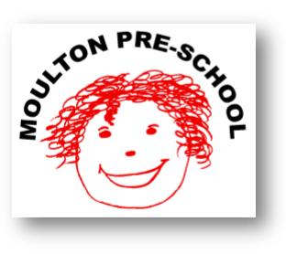

Induction and Probationary Period

Moulton Pre-school is committed to safeguarding and promoting the welfare of children, young people and adults at all times and expects everybody working within this setting to share this commitment.

Policy statement
We provide an induction for all employees and volunteers in order to fully brief them about the setting, the families we serve, our policies and procedures, curriculum and daily practice.

Induction
We have a written induction plan for all new staff, which includes the following:
- Introductions to all employees and volunteers.
- Familiarisation with the building, health and safety, and fire and evacuation procedures.
- Ensuring our policies and procedures are read and adhered to.
- Introduction to the parents, especially parents of allocated key children where appropriate.
- Familiarisation with confidential information in relation to any key children where applicable.
- Details of the tasks and daily routines to be completed.

The induction period lasts at least two weeks and forms part of the probationary period.
During the induction period, the individual must demonstrate understanding of and compliance with policies, procedures, tasks and routines.
Failure to complete the induction process could mean that the employees' probationary period is not confirmed.
Following induction, we continue to support our staff to deliver high quality performance through regular supervision and appraisal of their work.

Probationary Period

Employment is subject to satisfactory completion of the probationary period stated in the employees Contract of Employment. The company reserves the right to extend this period at its discretion.

During the probationary period, we will hold regular probation review meetings which are aimed to ensure the employee fully understands their role and what is required of them and is undergoing all necessary training whilst also allowing the employee a chance to air any issues or concerns they might be having.

Any issue or concern relating to the standard or performance of work will be discussed as soon as possible and will not wait for the probationary review meetings.

During the probationary period, absence management will be dealt with using the probationary review meetings.

If at the end of the probationary meeting, the standards required have not been met then Moulton Pre-school will either extend of fail the probationary period. Failing the probationary period means the contract will be terminated.

An employee should not consider their probationary period as having been successfully passed until they have received confirmation of this in writing from the Pre-school Manager.

