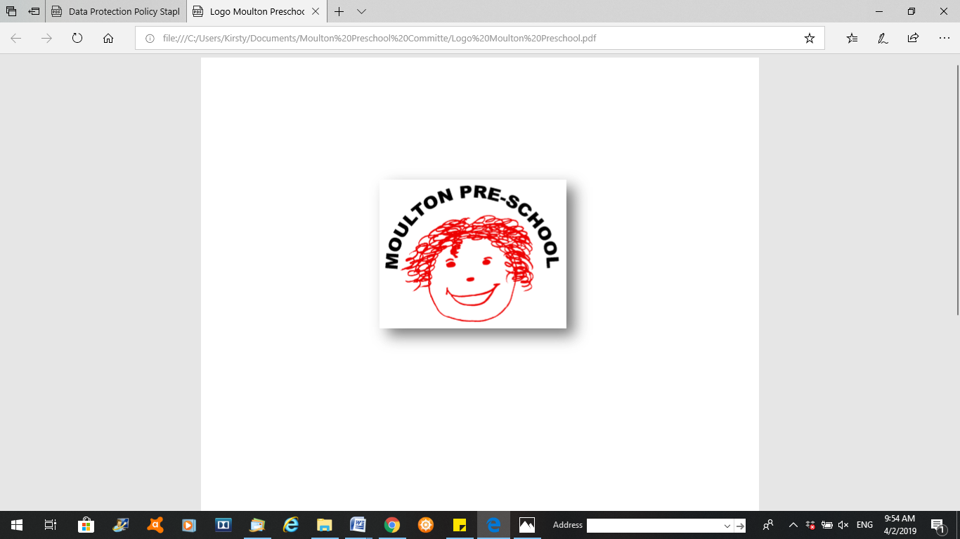

**Moulton Pre-School – Health and Safety Policy**

|  |  |
| --- | --- |
| **Version:** | 3.0 |
| **Author:** | Emily Short |
| **Approved and signed by:** | Moulton Pre-School Committee |
| **Date:** | March 2024 |
| **Review Date:** | 01/04/2026 |

# Health and Safety

***Moulton Pre-school is committed to safeguarding and promoting the welfare of children, young people and adults at all times and expects everybody working within this setting to share this commitment.***

**Aim**

Our provision is a suitable, clean and safe place for children to be cared for, where they can grow and learn. We meet all statutory requirements for health and safety and fulfil the criteria for meeting the Early Years Foundation Stage Safeguarding and Welfare Requirements.

**Objectives**

* We recognise that we have a corporate responsibility and duty of care towards those who work in and receive a service from our provision. Individual staff and service users also have responsibility for ensuring their own safety as well as that of others. Adherence to policies and procedures and risk assessment is the key means through which this is achieved.
* Insurance is in place (including public liability) and an up-to-date certificate is always displayed.
* Risk assessment is carried out where it is helpful to do so, to ensure the safety of children, staff, parents, and visitors. Legislation requires all those individuals in the given workplace to be responsible for the health and safety of premises, equipment and working practices.
* Smoking and vaping are not allowed on the premises, both indoors and outdoors. If children use any public space that has been used for smoking or vaping, members of staff ensure that there is adequate ventilation to clear the atmosphere. Staff do not smoke or vape in their work clothes and are requested not to smoke or vape within at least one hour of working with children. The use of electronic cigarettes is not allowed on the premises. S*ee Smoking, Alcohol and Substance Misuse Policy.*
* Staff must not be under the influence of alcohol or any other substance which may affect their ability to care for children. If staff are taking medication that they believe may impair them, they seek further medical advice and only work directly with children if that advice is that the medication is unlikely to impair their ability to look after children. The setting manager must be informed. S*ee Smoking, Alcohol and Substance Misuse Policy.*
* Alcohol must not be bought onto the premises for consumption. S*ee Smoking, Alcohol and Substance Misuse Policy.*
* A risk assessment and access audit are carried out for each area as required and the procedure is modified according to needs identified for the specific environment.
* Risk assessments are monitored and reviewed by those responsible for health and safety.

The safety of young children is of paramount importance. In order to ensure the safety of both children and adults, the pre-school will ensure safety in the following areas:

## Environment

* Safety checks on premises, both outdoors and indoors, will be made before every day/session.
* Low-level glass will be covered or replaced by safety glass.
* Outdoor space will be securely fenced.
* Public space used for outdoor play will be checked for litter and other dangers.
* Equipment will be checked regularly, and any dangerous items repaired/discarded.
* The layout and space ratios will allow children and adults to move safely and freely between activities.
* There will be adequate systems and equipment for the detection and control of fire.
* Fire doors will never be obstructed, and fire exits will be easily identifiable.
* A record will be kept of any checks by the Fire Safety Officer and also of fire drills and servicing of fire safety equipment. Any recommendations by the Fire Safety Officer will be carried out.
* Fires/heaters/electric points/wires and leads will be adequately guarded.
* All dangerous materials, including medicines and cleaning materials, will be stored out of reach of children.
* Large equipment will be erected with care and checked regularly.
* Equipment offered to children will be developmentally appropriate, recognising that materials suitable for an older child may pose a risk to younger/less mature children.
* Internal safety gates/barriers will be used as necessary.

## Supervision

* All children will be supervised by adults at all times and will always be within sight of an adult.
* Children will leave the group only with authorised adults.
* Children will not have unsupervised access to kitchens, cookers or any cupboards storing hazardous materials including matches.
* If a small group goes out, there will be sufficient adults to maintain appropriate ratios for staff and children remaining on the premises.
* Whenever children are on the premises at least two adults will be present

## Adult safety

* All adults in the group, both staff and visitors, will be aware of and respect the group’s safety policies.
* Adults in the group will have access to advice on safe lifting.
* If adults need to reach up for stored equipment, they will be provided with something safe to stand on. Heavy materials will not be stored above head height.
* Adults will not be required to be in the building alone, or to leave the premises alone after dark.

## Management

* A book will be available at each session for the reporting of any accidents/incidents.
* Regular safety monitoring will include checking of the accident record as a basis for risk assessment.
* All adults, including parents and other carers, will be aware of the system(s) in operation for children's arrivals and departures and an adult will be at the door during these periods.
* Adults will not walk about with hot drinks or place hot drinks within reach of children.
* Fire drills will be held at least twice a term.
* A register of both adults and children will be completed as people arrive and leave so that a complete record of all those present is available in any emergency.
* The No Smoking Policy is upheld at all times on the premises.
* A correctly stocked first aid box will be available at all times.
* Fire extinguishers will be checked annually, and staff will know how to use them.

## Special considerations

Some areas and activities pose particular hazards. All staff will be aware of these:

* Children playing with or near water will be continuously supervised.
* There will be safe surfaces beneath and around all climbing equipment and such activities will be appropriately supervised.
* All cooking activities involving the use of heat will be continuously supervised. Children will not be allowed in the kitchen for any other purpose.
* In shared premises, stored equipment belonging to other organisations will be checked for potential hazards.
* Access to dangerous areas such as stairways will be physically restricted and closely supervised.
* Systems will be in place to ensure that children are not at risk from swinging doors.
* Systems will be in place to ensure that no child can leave the premises unattended

**Legal references**

* Health and Safety at Work etc Act 1974
* Health and Safety (Consultation with Employees) Regulations 1996
* Management of Health and Safety at Work Regulations (1999)
* Regulatory Reform (Fire Safety) Order 2005)
* Electricity at Work Regulations (1989)
* Regulation (EC) No 852/2004 of the European Parliament and of the Council on the hygiene of foodstuffs
* Manual Handling Operations Regulations (1992) (Amended 2002)
* Medicines Act (1968)
* Reporting of Injuries, Diseases and Dangerous Occurrences Regulations (RIDDOR) (Amendment) Regulations 2012
* Control of Substances Hazardous to Health (COSHH) Regulations 2004
* Health and Safety (First Aid) Regulations 1981
* Childcare Act 2006
* **Further guidance**
* [Dynamic Risk Management in the Early Years](https://portal.eyalliance.org.uk/Shop#!prod/d28ed1d4-7564-ea11-a811-000d3a0bad7c/curr/GBP) (Alliance Publication)
* Health and Safety Executive www.hse.gov.uk/risk
* Food Standards Agency [www.food.gov.uk](http://www.fod.gov.uk/)
* Ministry or Housing, Communities & Local Government [www.communities.gov.uk](https://preschoolla.sharepoint.com/sites/COMM/Shared%20Documents/Pubs/Pubs%20Print%20Promo/Pub%20Drafts/A030%20Was%20A026%20Policies%20%26%20Procedures%20for%20the%20EYFS%202021/A030%20FINAL/www.communities.gov.uk)