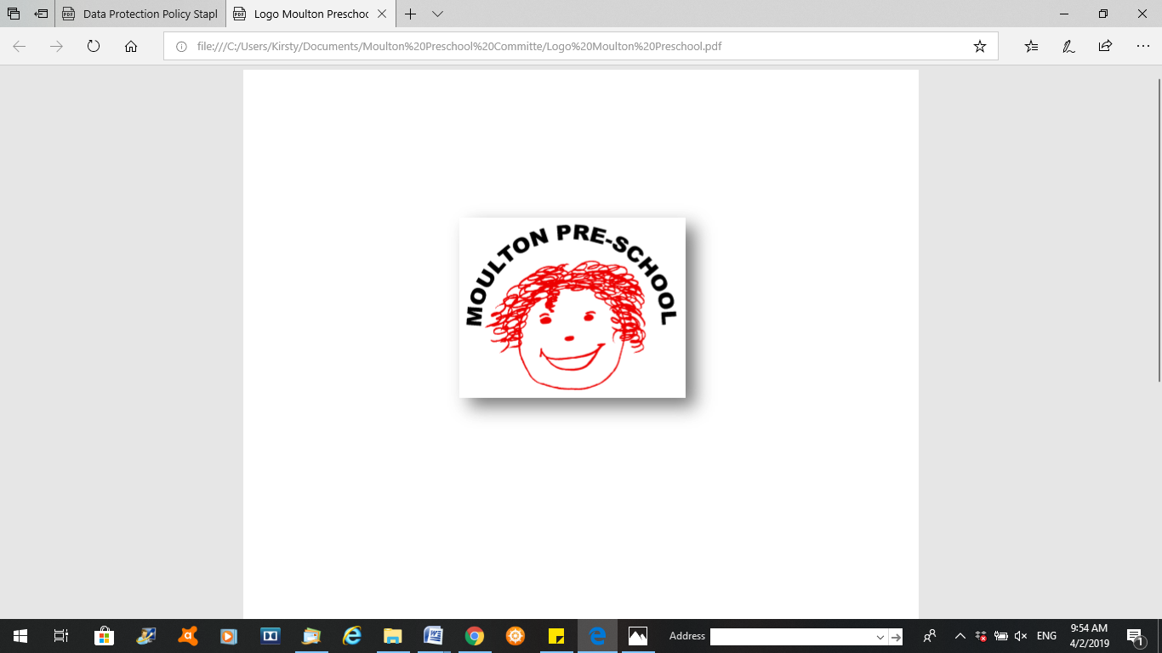

**Moulton Pre-School – Emergency evacuation procedure**

|  |  |
| --- | --- |
| **Version:** | 2.1 |
| **Author:** | Alexander Bowers |
| **Approved and signed by:** | Moulton Pre-School Committee |
| **Date:** | March 2024 |
| **Review Date:** | 01/04/2026 |

# Emergency Evacuation Procedure

***Moulton Pre-school is committed to safeguarding and promoting the welfare of children, young people and adults at all times and expects everybody working within this setting to share this commitment***

In the event of a fire/emergency the whistle will be blown. The exit door will be pointed out and named so that staff, adults and children know which door to go to.

The pre-school deputy will withdraw everyone away from the fire.

## The deputy manager will:-

* Collect the emergency box., which contains:
* Register with contact details
* First Aid Kit
* Message Book
* Pre-school Mobile Phone
* Gather the children and evacuate the building, leading everyone to the edge of the car park in front of the hall
* Call the register to check all children and adults are present.

On leaving the building a **designated member of staff** will count the children out.

## The Manager will:-

If safe to do so:

* Check the toilet area and close all doors to the toilet and corridor on way out.
* Close all windows and doors
* Turn lights off
* Dial 999

Another **designated member of staff** will, if safe to do so:-

* Check the book area and in the cosy den and close the kitchen door and kitchen shutters.
* Once every one is accounted for the Manager will assess the situation, and then nominate an adult to await instruction from the fire officer, while the rest of the group proceeds to Moulton School to contact the parents/carers to collect their children.
* We will ensure that staff and children are fully conversant with our fire drill by practicing the procedure for a period of one week each half term.