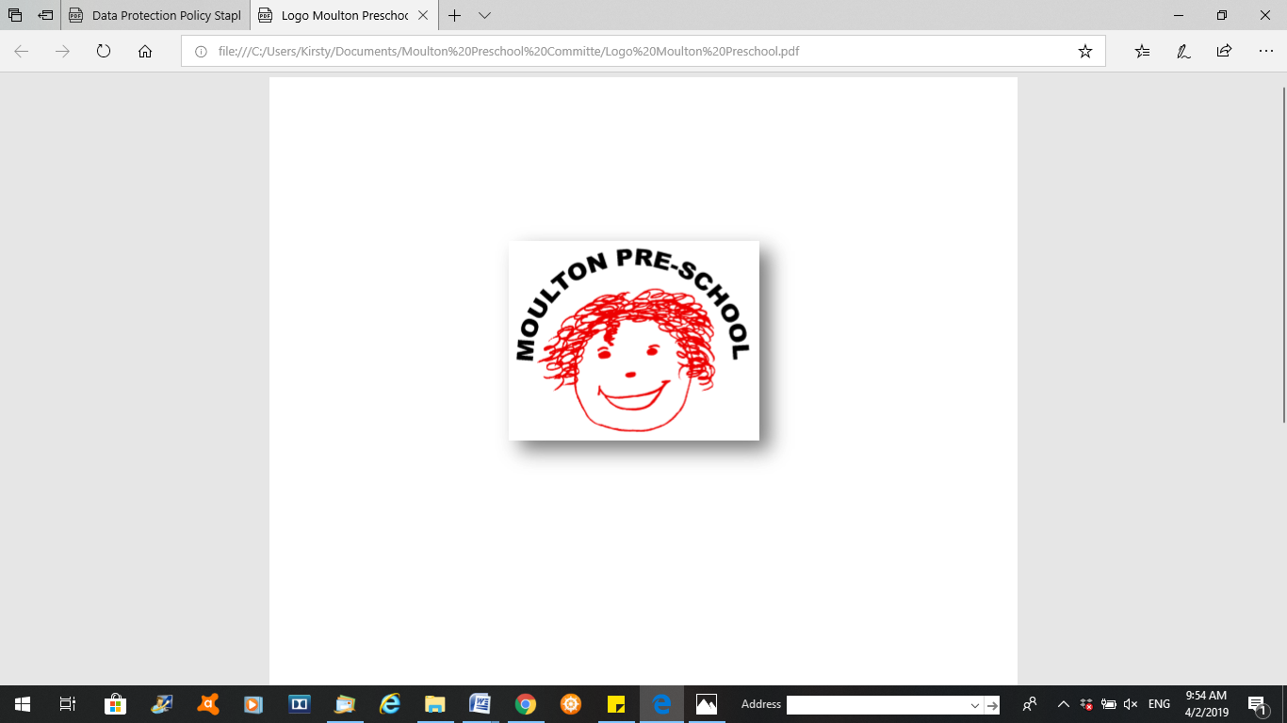

**Moulton Pre-School – Intimate Care Policy**

|  |  |
| --- | --- |
| **Version:** | 2.1 |
| **Author:** | Alexander Bowers |
| **Approved and signed by:** | Moulton Pre-School Committee |
| **Date:** | January 2024 |
| **Review Date:** | 01/04/2026 |

# Intimate Care Policy

***Moulton Pre-school is committed to safeguarding and promoting the welfare of children, young people and adults at all times and expects everybody working within this setting to share this commitment.***

09 Early years practice procedures

**09.9 Prime times – Intimate care and nappy changing**

## Policy statement

No child is excluded from participating in our setting who may, for any reason, not yet be toilet trained and who may still be wearing nappies or equivalent. We work with parents towards toilet training, unless there are medical or other developmental reasons why this may not be appropriate at the time.

We make necessary adjustments to our bathroom provision and hygiene practice in order to accommodate children who are not yet toilet trained.

We see toilet training as a self-care skill that children have the opportunity to learn with the full support and non-judgmental concern of adults.

At Moulton Pre-school we believe that every child should feel clean and comfortable.

and we will hold the dignity of the child in high priority

## Aim

* We aim to assist with each child’s toilet training by encouraging the use of our toilets, regardless of wearing a nappy/pull-ups.
* To change a child as and when is necessary and providing equipment to do so.

**Procedure details**

Prime times of the day make the very best of routine opportunities to promote ‘tuning-in’ to the child emotionally and to create opportunities for learning. Nappy changing times are key times in the day for being close and promoting security as well as for communication, exploration and learning.

**Babies**

* Babies/young children are usually changed within sight or hearing of other staff whilst maintaining their dignity and privacy at all times. Where the layout of the setting makes this difficult to achieve, the setting manager completes a risk assessment to ensure that alternative arrangements are in place
* Key persons have a list of personalised changing or checking times for the babies and toddlers in their care.
* Key persons undertake changing babies in their key groups wherever possible; back up key persons change them if the key person is absent.
* Nappy changing areas are warm; there are no bright lights shining down in babies’ eyes.
* There are mobiles or other objects of interest to take the baby’s attention.
* Each baby has their own basket to hand, containing their nappies and changing wipes; there may also be a special toy for the baby to play with.
* Members of staff put on aprons before changing starts and the area is prepared, gloves are always worn for soiled nappies.
* All members of staff are familiar with the hygiene procedures and carry these out when changing nappies.
* Key persons ensure that nappy changing is relaxed and a happy time for babies.
* Key persons never turn their back on a child or leave them unattended on a changing mat.
* Key persons are gentle when changing; they allow time for communicating with the baby, talking, and responding to the baby’s sounds. They allow time for play and ‘rituals’ that the baby enjoys, such as gently tickling tummies or toes.
* Key persons avoid pulling faces and making negative comment about the nappy contents.
* Key persons do not make inappropriate comments about babies’ genitals, nor attempt to pull back a baby boy’s foreskin to clean unless there is a genuine need to do so for hygiene purposes.

**Nappy changing records.**

* Key persons record when they changed the baby and whether the baby passed a stool and if there was anything unusual about it e.g. hard and shiny, soft and runny or an unusual colour.
* If the baby does not pass a stool, or if he/she strains to do so, or is passing hard or shiny stools, the parents will be informed. The baby may be constipated so their feed may need to be adjusted. Constipation in babies is not ‘normal’ and every effort is made with the parent to help them adjust the diet until soft, formed stools are passed.
* A stool that is an unusual colour can usually be related to the food that was eaten, so it is important that this is noted. However, a stool that is black, green or very white indicates a problem, and the child should be taken to the doctor.
* Very soft, watery stools are signs of diarrhoea; strict hygiene needs to be carried out in cleaning the changing area to prevent spread of infection. The parent should be called to inform them, and that if any further symptoms occur they may be required to collect their child.
* Sometimes a baby may have a sore bottom. This may have happened at home as a result of poor care; or the baby may have eaten something that, when passed, created some soreness. The baby also may be allergic to a product being used. This must be noted and discussed with the parent and a plan devised and agreed to help heal the soreness. This may include use of nappy cream or leaving the baby without a nappy in some circumstances. If a medicated nappy cream such as Sudocrem is used, this must be recorded as per procedure 04.2 Administration of medicine.

**Young children, intimate care and toileting**

* Wherever possible, key persons undertake changing young children in their key groups; back-up key persons change them if the key person is absent.
* Young children from two years may be put into ‘pull ups’ as soon as they are comfortable with this and if parents agree.
* Gloves and aprons are put on before changing starts and the areas are prepared
* All staff are familiar with the hygiene procedures and carry these out when changing nappies.
* Changing areas are warm, appropriately sited and there are safe areas to lay young children if they need to have their bottoms cleaned. There are mobiles or other objects of interest to take the child’s attention.
* If children refuse to lie down for nappy change, they can be changed whilst standing up, providing it is still possible to clean them effectively.
* Each young child has his/her own basket to hand with their nappies/pull ups and changing wipes.
* Key persons ensure that nappy changing is relaxed and a time to promote independence in young children.
* Young children are encouraged to take an interest in using the toilet; they may just want to sit on it and talk to a friend who is also using the toilet.
* They are encouraged to wash their hands and have soap and paper towels to hand. They should be allowed time for some play as they explore the water and the soap.
* Anti-bacterial hand wash liquid or soap should not be used by young children, as they are no more effective than ordinary soap and water.
* Key persons are gentle when changing and avoid pulling faces and making negative comment about the nappy contents.
* Wipes or cotton wool and water are used to clean the child. Where cultural practices involve children being washed and dried with towels, staff aim to make reasonable adjustments to achieve the desired results in consultation with the child’s parents. Where this is not possible it is explained to parents the reasons why. The use of wipes or cotton wool and water achieves the same outcome whilst reducing the risk of cross infection from items such as towels that are not ‘single use’ or disposable.
* Key persons do not make inappropriate comments about young children’s genitals when changing their nappies.
* The procedure for dealing with sore bottoms is the same as that for babies.
* Older children use the toilet when needed and are encouraged to be independent.
* Members of staffs do not wipe older children’s bottoms unless there is a need, or unless the child has asked.
* Key persons are responsible for changing where possible. Back-up key persons take over in the key person’s absence, but where it is unavoidable that other members of staff are brought in, they must be briefed as to their responsibilities towards designated children, so that no child is inadvertently overlookedand that all children’s needs continue to be met.
* Parents are encouraged to provide enough changes of clothes for ‘accidents when children are potty training.
* If spare clothes are kept by the setting, they are ‘gender neutral’ i.e. neutral colours, and are clean, in good condition and are in a range of appropriate sizes.
* If young children are left in wet or soiled nappies/pull-ups in the setting, this may constitute neglect and will be a disciplinary matter.

Nappy changing is always done in an appropriate/designated area. Children are not changed in play areas or next to snack tables. If there are limitations for nappy change areas due to the lay-out of the room or space available this is discussed with the setting manager’s line manager so that an appropriate site can be agreed that maintains the dignity of the child and good hygiene practice.

## Method

* We will provide a safe and clean area in the way of the disable toilet which to clean and change a child.
* Staff will not close themselves in the room and will inform another member of staff they are changing a child
* We provide disposable gloves and aprons for the staff to wear each time a child is changed.
* We provide a changing mat and clean towel on which to change the child, and are cleaned after each use.
* We request parents to provide a bag on their child’s peg at each session, containing a change of clothes and nappies/pull ups if apply.
* We do have a limited supply of change of clothes.
* We use sensitive baby wipes for cleaning a child but we will always check with parents in case of any allergies.
* A changing slip will be filled in and placed in the child’s book bag.
* All dirty nappies/pull ups are disposed of in a nappy bag and placed in the outside bin when finished changing the child.
* All dirty clothes are put in a plastic carrier bag and kept away from the children and are then handed to the parent/carer upon collection of the child.