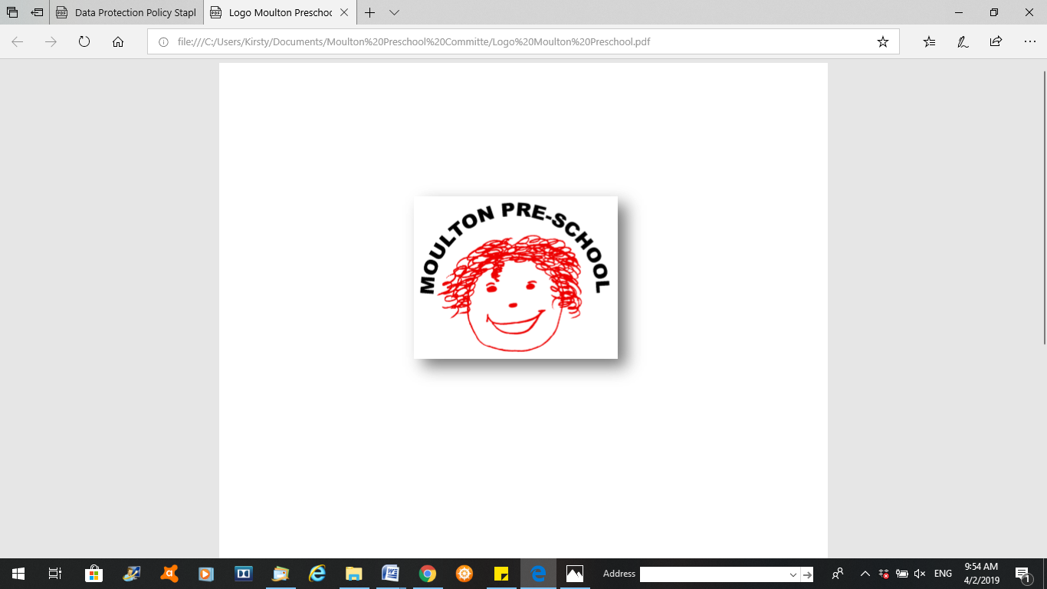

**Moulton Pre-School – Visitors or Intruders Policy**

|  |  |
| --- | --- |
| **Version:** | 3.0 |
| **Author:** | Emily Short |
| **Approved and signed by:** | Moulton Pre-School Committee |
| **Date:** | March 2024 |
| **Review Date:** | 01/04/2026 |

**Visitor or intruder on the premises**

***Moulton Pre-school is committed to safeguarding and promoting the welfare of children, young people and adults at all times and expects everybody working within this setting to share this commitment.***

## Policy statement

Moulton Pre-School is committed to providing a safe and secure environment for all the children and adults on our premises. The safeguarding for all children and adults is of paramount importance to us. Therefore we take the following procedures when any adult is visiting the pre-school.

**Visitors with legitimate business -** generally a visitor will have made a prior appointment

* On arrival, they are asked to verify their identity and confirm who they are visiting.
* Visitors must sign the visitors book with the date, time of arrival/departure, name and purpose of visit
* All visitors must adhere to the preschool policy on mobile phone, camera and electronic devices.
* If staff requires further reassurance of the identity of the visitor they will phone the employing organisation of the visitor.
* The identity of any unknown or unannounced visitors must be checked before they are permitted to enter the setting
* Visitors must be supervised by a member of staff at all times
* No visitor will be left alone with the children at any time or accompany children to the toilet
* Prospective children and parents are welcomed to visit the pre-school prior to joining
* No unauthorised adults are allowed into the setting during sessions
* We have the right to refuse an individual entry to the setting and will do so if we are unsure of the purpose of their visit.

**Intruder**

* An intruder is an individual who has not followed visitor procedures and has no legitimate business to be in the setting; he or she may or may not be a hazard to the setting.
* An individual who appears to have no business in the setting will be asked for their name and purpose for being there.
* The staff member identifies any risk posed by the intruder.
* The staff member ensures the individual follows the procedure for visitors.
* The setting manager is immediately informed of the incident and takes necessary action to safeguard children.
* If there are concerns for the safety of children, staff evacuate them to a safe place in the building and contact police. In some circumstance this could lead to ‘lock-down’ of the setting and will be managed by the responding emergency service (see procedure 01.21 Terrorist threat/attack and lock-down).
* The designated safeguarding lead informs their designated officer of the situation at the first opportunity.
* In the case of a serious breach where there was a perceived or actual threat to the safety of the children, the manager/designated person completes 06.1c Confidential safeguarding incident report form) and copies in their line manager on the day of the incident. The owners/trustees/directors ensure a robust organisational response and ensure that learning is shared.