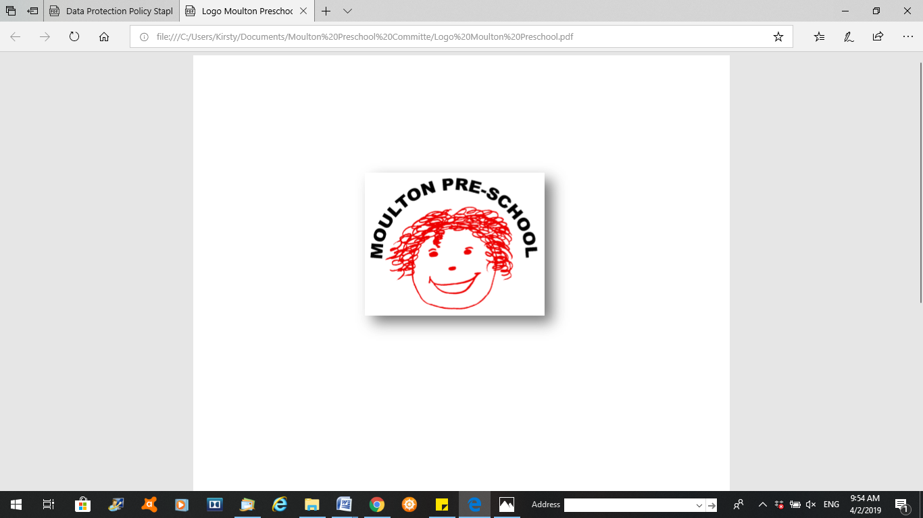

**Moulton Pre-School – Health and Hygiene Policy and Practice**

|  |  |
| --- | --- |
| **Version:** | 2.1 |
| **Author:** | Emily Short |
| **Approved and signed by:** | Moulton Pre-School Committee |
| **Date:** | March 2024 |
| **Review Date:** | 01/04/2026 |

# Health & Hygiene - Policy and Practice

***Moulton Pre-school is committed to safeguarding and promoting the welfare of children, young people and adults at all times and expects everybody working within this setting to share this commitment.***

Our pre-school promotes a healthy lifestyle and a high standard of hygiene in its day-to-day work with children and adults. This is achieved in the following ways:

**Objectives**

We promote health through:

* ensuring emergency and first aid treatment is given where necessary
* ensuring that medicine necessary to maintain health is given correctly and in accordance with legal requirements
* identifying allergies and preventing contact with the allergenic substance
* identifying food ingredients that contain recognised allergens and displaying this information for parents
* promoting health through taking necessary steps to prevent the spread of infection and taking appropriate action when children are ill
* promoting healthy lifestyle choices through diet and exercise
* supporting parents right to choose complementary therapies
* pandemic flu planning or illness outbreak management as per DfE and World Health Organisation (WHO) guidance

## Health:

## Food

* All meals and snacks provided will be nutritious and pay due attention to children's particular dietary requirements.
* When cooking with children as an activity, the adults will provide healthy, wholesome food, promoting and extending the children's understanding of a healthy diet.

## Outdoor play

* Children will have the opportunity to play outside every day either in our own area or on the field throughout the year unless the weather is unsafe.

## Illness

* Parents are asked to keep their children at home if they have any infection, and to inform the pre-school as to the nature of the infection. This will allow the pre-school to alert other parents as necessary and to make careful observations of any child who seems unwell.
* Parents are asked not to bring into the pre-school any child who has been vomiting or had diarrhoea until at least 48 hours have elapsed since the last attack.
* If the children of pre-school staff are unwell, the children will not accompany their parents/carers to work in the pre-school.
* Cuts or open sores, whether on adults or children, will be covered with sticking plaster or other dressing.
* If the child is on prescribed medication the pre-school will follow the administering medication policy.
* With regard to the administration of life saving medication such as insulin/adrenalin injections or the use of nebulisers, the position will be clarified by reference to the pre-school's insurance company. (In the case of pre-schools insured with Royal & Sun Alliance, this will be through the Insurance section at Pre-school Learning Alliance National Centre). If specialist knowledge is required, staff involved in administering medication will receive training from a qualified health professional.

## First Aid

* In our setting staff are able to take action to apply first aid treatment in the event of an accident involving a child or adult. At least one member of staff with current first aid training is on the premises or on an outing at any one time. The first aid qualification includes first aid training for infants and young children.
* The pre-school will ensure that the first aid equipment is kept clean, replenished and replaced as necessary. Sterile items will be kept sealed in their packages until needed.
* The first aid box is easily accessible to adults and is kept out of the reach of children.
* No un-prescribed medication is given to children, parents or staff.
* At the time of admission to the setting, parents' written permission for emergency medical advice or treatment is sought. Parents sign and date their written approval.
* Parents sign a consent form at registration allowing staff to take their child to the nearest Accident and Emergency unit to be examined, treated or admitted as necessary on the understanding that parents have been informed and are on their way to the hospital.

## Hygiene:

To prevent the spread of all infection, adults in the group will ensure that the following good practices are observed

## Personal hygiene

* Hands washed after using the toilet and before handling food
* Children with pierced ears are not allowed to share each other's earrings.
* Children encouraged to blow and wipe their noses when necessary and to dispose of soiled tissues hygienically
* Paper towels are used and disposed of appropriately.
* Hygiene rules related to bodily fluids followed with particular care and all staff and volunteers aware of how infections, including HIV infection, can be transmitted.

## Cleaning and clearing

* Any spills of blood, vomit or excrement wiped up and flushed away down the toilet. Rubber gloves are always used when cleaning up spills of body fluids. Floors and other affected surfaces are disinfected using bleach diluted according to the manufacturer's instructions. Fabrics contaminated with body fluids thoroughly washed in hot water.
* Spare laundered pants and other clothing available in case of accidents, and polythene bags available in which to wrap soiled garments.
* All surfaces cleaned daily with an appropriate cleaner

## Food

The pre-school will observe current legislation regarding food hygiene, registration and training.

In particular, each adult will:

* Always wash hands under running water before handling food and after using the toilet.
* Not be involved with the preparation of food if suffering from any infectious/contagious illness or skin trouble.
* Never smoke in the kitchen or in any room storing food.
* Never cough or sneeze over food.
* Use different cleaning cloths for kitchen and toilet areas.
* Prepare raw and cooked food in separate areas.
* Keep food covered and either refrigerated or piping hot.

## Legal framework

* Medicines Act (1968)
* Reporting of Injuries, Diseases and Dangerous Occurrences Regulations 2013 (RIDDOR)
* Control of Substances Hazardous to Health (COSHH) Regulations (2002)
* Health and Safety (First Aid) Regulations 1981
* Food Information Regulations 2014

## Further guidance

* First Aid at Work: Your questions answered (HSE Revised 2009)
* Basic Advice on First Aid at Work (HSE Revised 2008)
* Guidance on First Aid for Schools (DfEE)

# Information sources

* Parents will have the opportunity to discuss health issues with pre-school staff and will have access to information available to the pre-school.
* The pre-school will maintain links with health visitors and gather health information and advice from the local health authority information services and/or other health agencies.